Architecture Planning Notes
Use the prompts below to organize your ideas before creating the diagram.
Platform Users
- Learners: To learn new materials and evaluate what they have learned through modules and assessments.
- Developers: To create/make changes and evaluate the changes and to monitor the system through active monitoring system, also intake feedback from business and technical stakeholders to make further changes
Platform Entry and Traffic
How will incoming requests be protected?
- HTTPS/TSL encryption: Encrypt data in transit helps to prevent interception and injections.
- IAM: Proper identity and access control prevents unauthorized access
- Rate Limiting: Limitation to number of attempts from a single IP prevents DDOs.
- Input Validation: Creation of rules for all incoming data against for type, length, and format to block injection attacks.
How will traffic be distributed during busy periods?
- Auto-Scaling: Adding a Load Balancer will allow to set rules for auto-scaling (to either scale-down at certain CPU usage or scale-down at certain CPU usage).
- Content Delivery Network (CDN): It caches static assets (images, scripts, HTML) on edge servers globally, offloading up to 70-80% of requests from your origin servers.
Core Application
- A separate server will be assigned for handling learner sign-in, course access, assessment, completion tracking, where each of these activities will be registered as separate services which are linked to each other. Same Relational database will be used for these records where each record will have its own table and connected to each other through foreign keys
- As for the administrative activities, it will be added to the admin server so that this task will not be accessed by the learners.
- Doing so will allow the developers to set the load balancer in a way which will allow the servers to increase or decrease capacity based on traffic.
Content and Data
- Cloud Object Storage is a way to store all kinds of files like videos and images and documents. It is very durable. Can store a lot of data. This is because it uses a bucket system that's similar to AWS S3. This means we do not have to store files on our server drives.
- We also have a Global Content Delivery Network which's like a big network of servers all around the world. It stores our course materials in these servers so that when someone wants to access them, they can get them from the server that's closest to them. This helps to reduce the traffic on our storage system by up to 80 percent. It also means that people can watch videos without any interruptions.
- Our Adaptive Media Streaming feature is very useful. It takes the videos we upload and converts them into a format that can be streamed easily. This means that the video quality will adjust automatically based on the internet speed of the person watching it.
- We take the security of our content seriously. That is why we use something called Secure Tokenized Access. This means that only people who are allowed to access our content can do so. We use links that are only valid for a short time to protect our content from being shared or downloaded by unauthorized people.
- We use a Relational Database Management system to store data like learner accounts and quiz scores. This system is very good at making sure our data is safe and accurate.
- We also have Database Read Replicas. This means that we have databases for administrative tasks and for student traffic. This helps to prevent platform from slowing down during periods, like exam times.

Monitoring and Recovery
- Since most of the services will be shifted to a cloud-based structure, techniques like grafhana, promethous, cloudwarch could be implemented for proper system monitoring. They provide real-time system monitoring.
- Conditions such as failure-recovery unsuccessful, deadlock, server errors, unauthorized access, calculation failures, connection errors, etc. should generate an alert. These are some of the main causes of system unavailability and can cause a lot of learners to be dissatisfied or unable to reach the system.
- Services like Database Read Replication, Anycast-routed Object Storage and Disaster recovery mechanisms will be implemented for data recovery after a failure

Proposed Solution Architecture
Instructions: Use the sections below to plan the structure of your architecture diagram. For each area, identify the component or service you believe should be included and explain its purpose. Do not add unnecessary details. Your goal is to create a clear, high-level design that a non-technical stakeholder can understand. After completing the planning tables, use the diagram workspace to arrange your selected components and show how they connect.

Suggested Starting Structure
You may use the structure below as a starting point, but you are not required to follow it exactly.
1. Platform Users
Identify the groups that will access or manage Elevate Learning’s platform.
Planning Prompt | Your Response
Who will use or manage the platform? | Use: Learners and other Business Stakeholders  Manager: Developers, Tester and other technical stakeholders
What activities will each group complete? | Learners: provide their login/signup credentials, select interested courses, access resources and videos for the selected course, complete assessments, review their result  Developer: Update Services according to costumer’s feedback, manage database related tasks, set up access control mechanisms along with auto-scaling, add load-balancing and IAMs, review the monitoring details, fix errors as per alerts
↓
2. Platform Entry and Security

Identify the components that should manage and protect incoming user requests.
Planning Prompt | Your Response
Component or service | IAM, HTTP/TSL, Rate Limiting
Purpose | Authorization and Authentication along with input validation
What happens to a user request at this stage? | It will grant access resources to users based on their specification and avoid unauthorized access.
In your diagram, show how approved requests move to the next stage of the platform.
↓
3. Traffic Distribution
Identify how incoming requests should be distributed across the available platform resources.
Planning Prompt | Your Response
Component or service | Load Balancing
Purpose | Distribute service across platform
How will this support performance and availability? | Depending upon traffic this mechanism will add or remove servers to keep up arability
↓
4. Core Application Services
Identify the components responsible for processing the platform’s main functions. Consider activities such as user access, course activity, assessments, completion tracking, and administrative tasks.
Planning Prompt | Your Response
Component or service | Auto-scaling
Main platform functions supported | learner and Admin services
How will this part of the platform respond when demand changes? | It will automatically scale up or down based on server utilization. This will prevent overconsumption of resources and reduce payload.
In your diagram, show separate connections from the core application to course content and learner data.
↓
5. Course Content and Media
Identify how course videos, images, documents, and other learning materials should be stored and delivered.
Planning Prompt | Your Response
Storage component or service | Object Storage
Delivery component or service | CDNs (Content Delivery Network)
How will this approach support platform performance? | Object storage are great for easy access and the use of proper CDN will ensure safe and proper content wise deilvery
↓
6. Learner Data
Identify how learner accounts, assessment results, and completion records should be stored and protected.
Planning Prompt | Your Response
Data component or service | Relational Database (RDBMS) for learner accounts, assessment results, and completion records
Reliability feature | Read replicas separate admin and student traffic, plus automated backups, so the platform stays responsive during peak periods like exam time
Security feature | Encryption at rest and in transit, with IAM-based access control
How will the solution protect important learner information? | Access is restricted through IAM roles and sensitive fields are encrypted, so only authorized services can read or modify learner data
↓

7. Monitoring and Operations
Identify how the technical team will observe the platform and respond to problems.
Planning Prompt | Your Response
Monitoring component or service | Grafana, Promethous or CloudWatch
What should be monitored? | Server health,darabases performance, API response times, error rates, storage/backup status, and unauthorized access attempts
What conditions should generate an alert? | Failed recovery attempts, deadlocks, server errors, unauthorized access, calculation failures, and connection errors.
Who should respond? | The on-call developer/technical operations team
In your diagram, connect monitoring to the parts of the platform that should be observed.
↓
8. Backup and Recovery
Identify how the platform will support restoration after a system failure or data loss.
Planning Prompt | Your Response
Backup or recovery component | Database read replication, Anycast routed object storage replication, and disaster recovery mechanisms
What information or content should be protected? | Learner accounts, assessment results, completion records, and course content/media
How will this support faster recovery? | Replicated data lets the platform fall over to a standby without a full restore, and geographically distributed storage keeps content available even if one region fails
In your diagram, show which platform components connect to backup and recovery.
Create Your Architecture Diagram
Using your responses above, create a high-level architecture diagram on the next page. Use boxes, arrows, and short labels to show how users, requests, course content, learner data, monitoring, and recovery connect across the proposed solution.
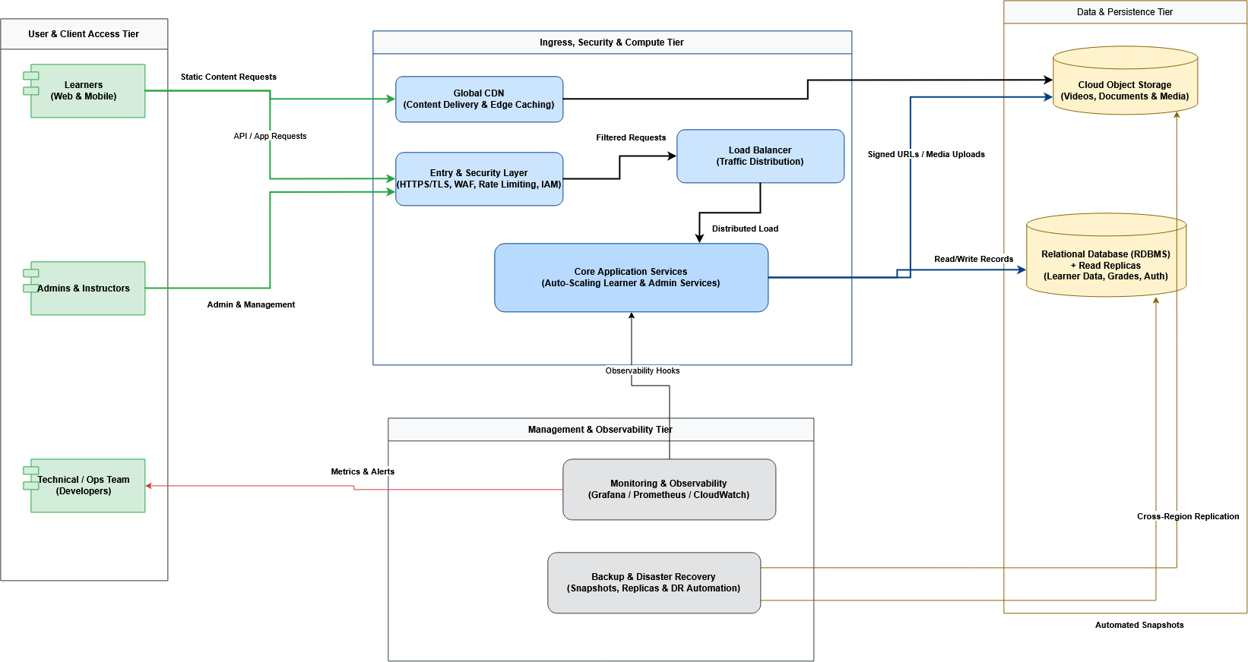

Architecture Rationale
Briefly explain how your proposed architecture addresses Elevate Learning’s needs. Keep each response concise and focus on how the components in your diagram support the client’s priorities.
Scalability
How will the proposed solution respond when learner demand increases?
Response:
- The Load Balancer and auto-scaling within the core application layer will add or remove server instances automatically based on traffic, so the platform can absorb spikes in learner demand during high traffic without manual intervention.
Reliability
How will the proposed solution reduce service disruption and maintain platform availability?
Response:
- Database read replicas separate administrative and sudden traffic, preventing server slowdown, also the CDN offloads up to 80% of content requests from origin servers and those combined with auto-scaling reduces the risk of any single component failure or bottleneck.
Security
How will the proposed solution protect users, systems, and learner information?
Response:
- Incoming requests pass through HTTP/TLS encryption. IAM-based auth, rate limiting and input validation before reaching the application layer
- Learner data is further protected through encryption at rest and role-based access control which ensures only authorized users and services can reach sensitive data/information.
Performance
How will the proposed solution support a responsive learner experience?
Response:
- The CDN caches course content at edge locations close to the learners and adaptive streaming adjusts video quality to each learner’s connection speed, minimizing the load times.
- Read replicas and the load balancer application layer keep response times consistent even under high traffic conditions.

Backup and Recovery
How will the proposed solution help the technical team restore services or data after a failure?
Response:
- Database read replications along with Anycast-routed object storage replication allows the platform to fail over to a standby copy without a full restore, while disaster recovery mechanisms protect learner accounts, assessment records, and course content against data loss.

